KOPS Bank ATM Application – User Documentation

**Group** **K**(*evin*) **O**(*stap*) **P**(*oulad*) **S**(*uthas*)

Contents

How to Run the Application 2

1. Open Eclipse 2

2. Import the zip file as a project 2

3. Run BankServer.java as a Java application. 4

You should now see this screen open: 5

4. Run AtmClient.java as a Java application 6

You should now see this screen open: 7

You should see this message on the Server GUI: 8

How to Test the Application 9

1. Bank Account Authentication 9

Invalid authentication 9

Valid authentication 9

2. Bank Account Balance Inquiry 11

3. Deposit of money 12

4. Withdrawal of money 13

Trying to withdraw more money than is available 14

5. Exiting the Application 16

User disconnecting when they have not logged in vs has logged in 18

# How to Run the Application

## Open Eclipse

## Import the zip file as a project

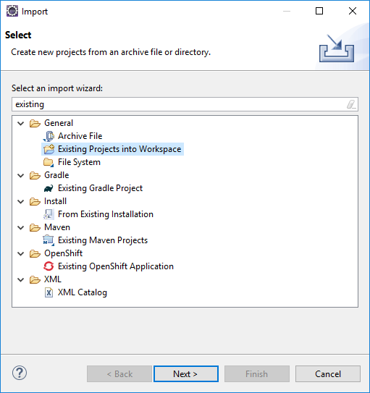

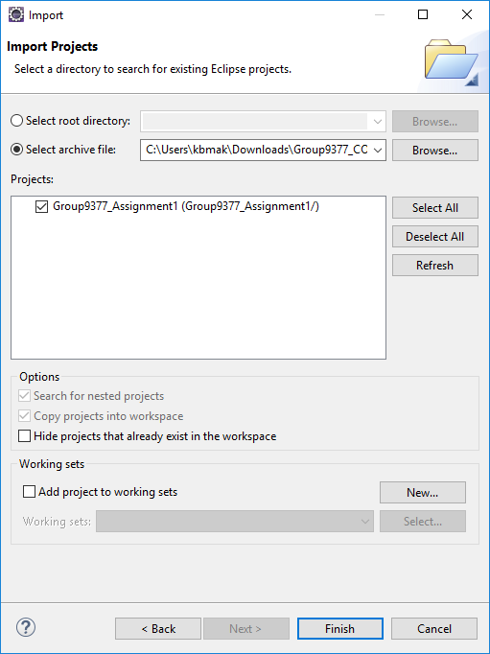

## Run BankServer.java as a Java application.

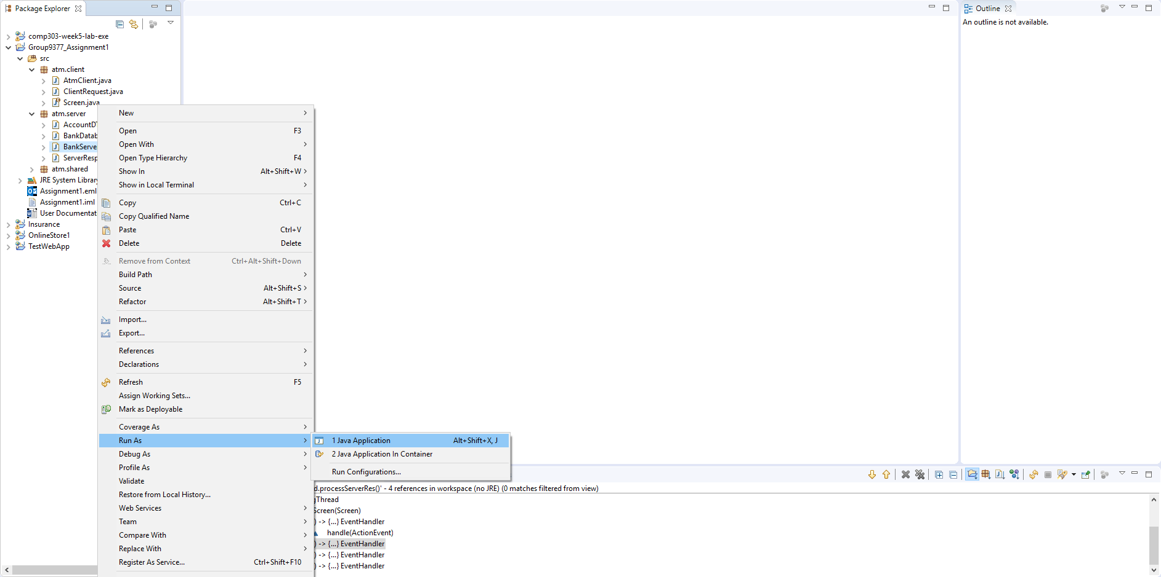

### You should now see this screen open:

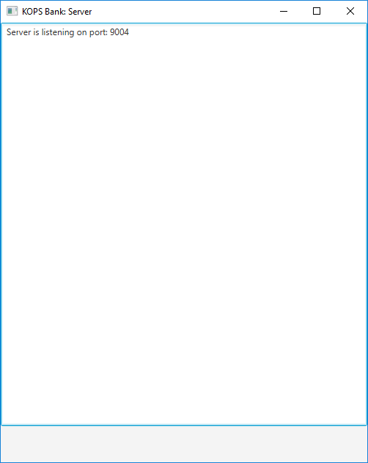

## Run AtmClient.java as a Java application

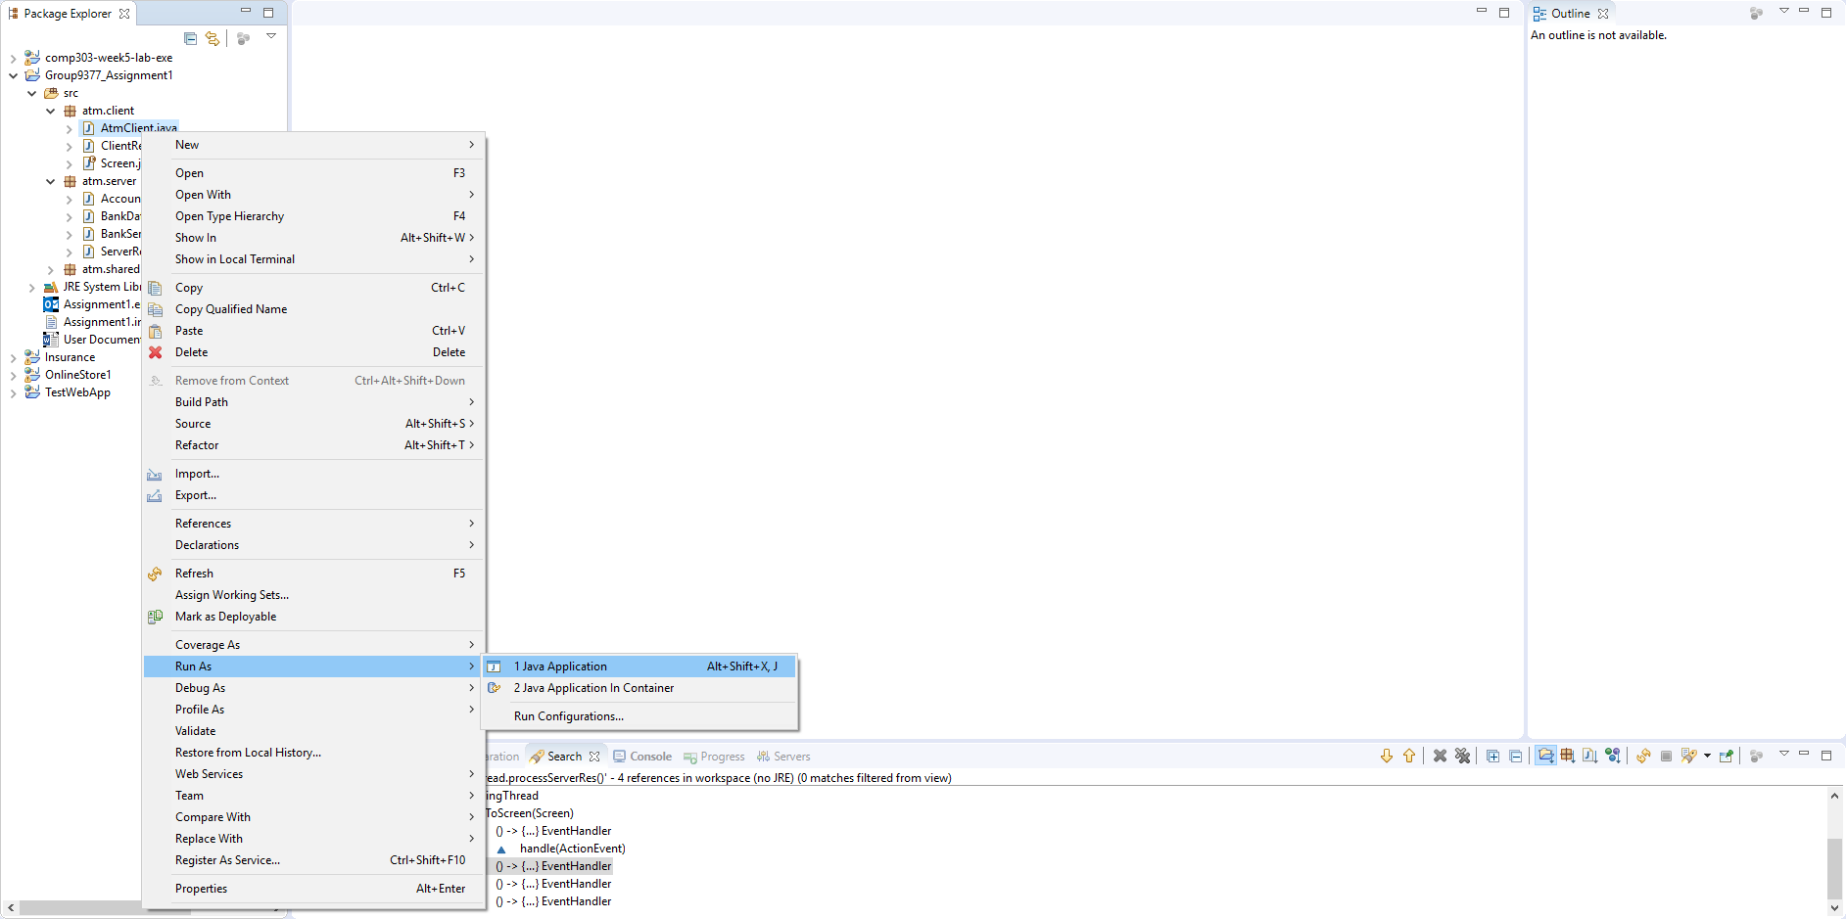

### You should now see this screen open:

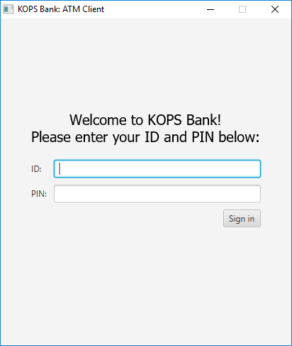

### You should see this message on the Server GUI:

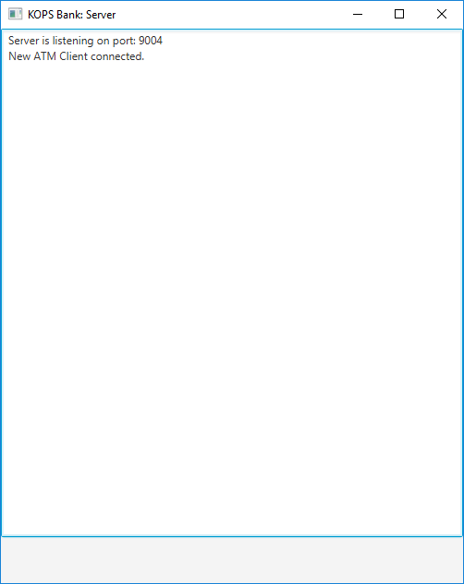

# How to Test the Application

## Bank Account Authentication

### Invalid authentication

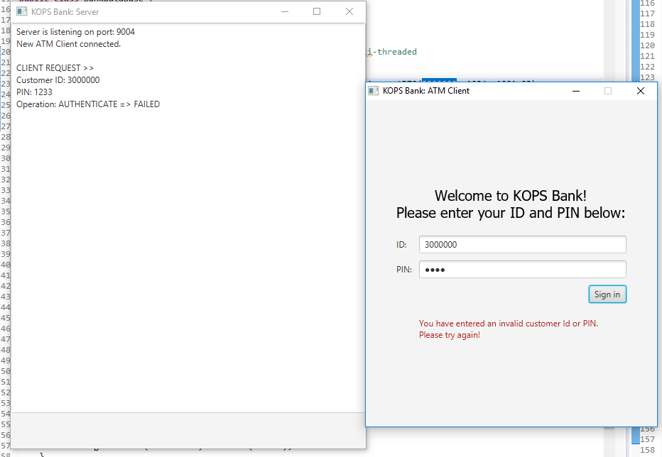

### Valid authentication

* + Open BankDatabase.java
  + Pick a Customer ID and matching Password

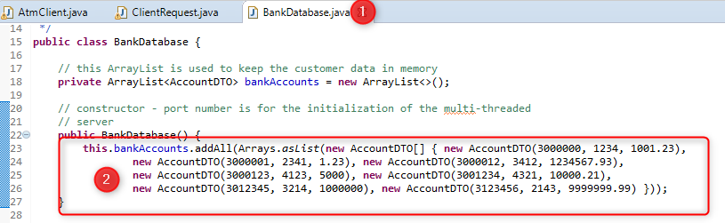

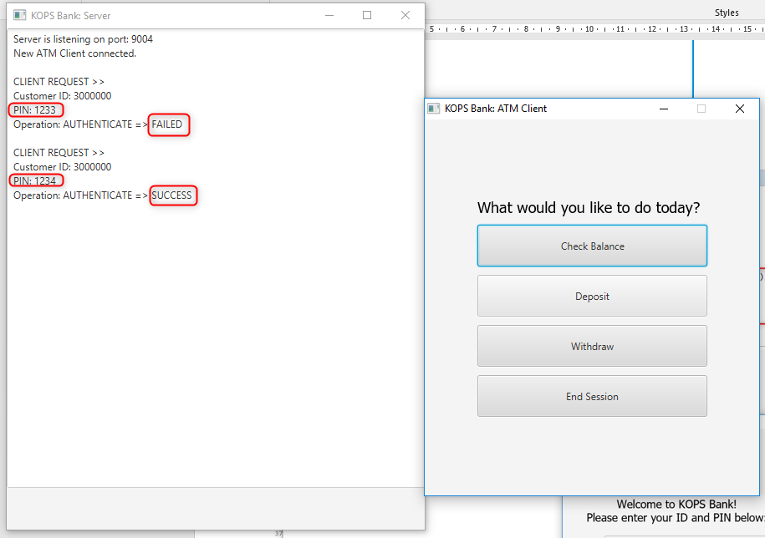

## Bank Account Balance Inquiry

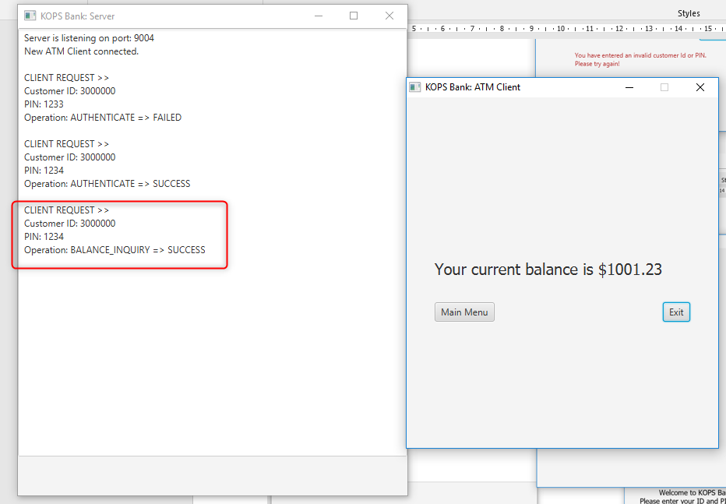

## Deposit of money

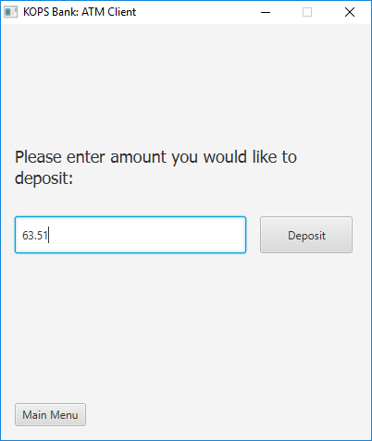

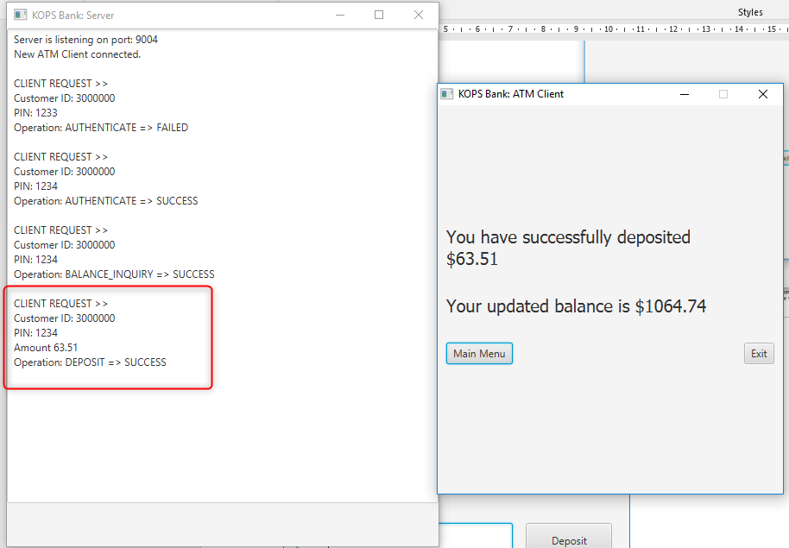

## Withdrawal of money

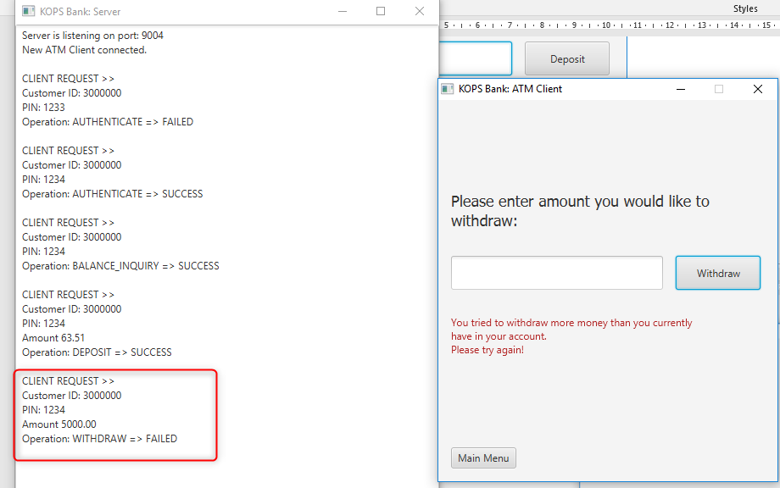

### Trying to withdraw more money than is available

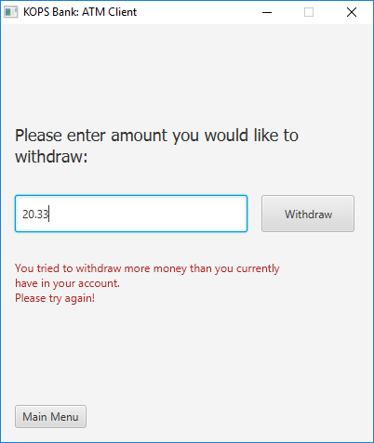

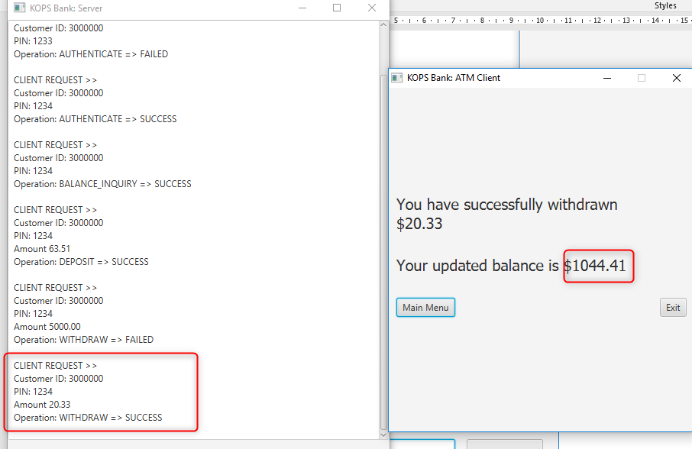

## Exiting the Application

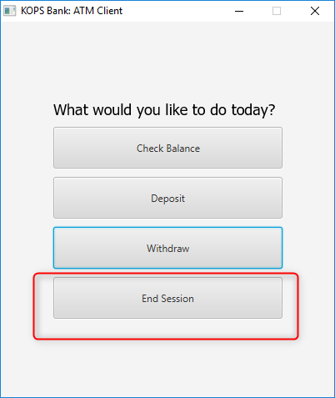

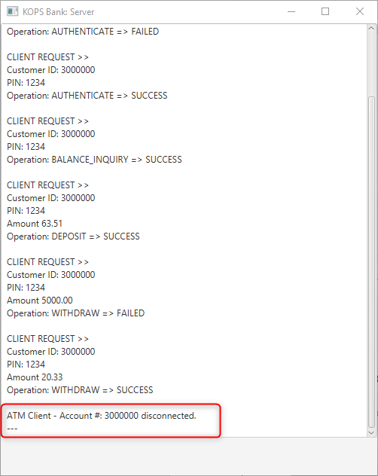

### User disconnecting when they have not logged in vs has logged in

